File Handling LO3
6-2-26
Aim – Demonstrate file handing in python.
Theory – File handling in Python allows programs to store and retrieve data permanently using files. It supports operations such as opening, reading, writing, and closing files. Functions like open(), read(), readlines(), and context managers (with) ensure efficient data processing and safe resource management.
A1.
file_name = "test.txt"
word_length = int(input("Enter desired word length: "))

file = open(file_name, 'r')
content = file.read()
file.close()

words = content.split()

print(f"Words with length {word_length}:")
for word in words:
cleaned_word = ""
for char in word:
if char.isalpha():
cleaned_word += char

if len(cleaned_word) == word_length:
print(cleaned_word)
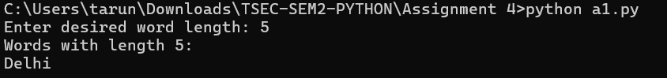
A2.
with open('test.txt', 'r') as file:
cities = file.readlines()
cities = [city.strip() for city in cities]
cities.sort()
for city in cities:
print(city)
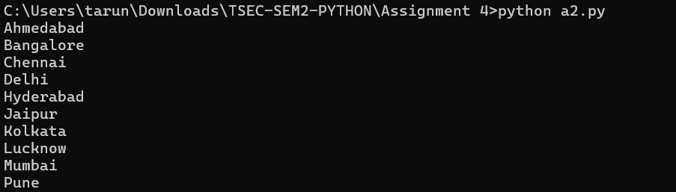

Conclusion
File handling is essential for working with external data in Python programs. Using proper methods and context managers helps prevent data loss and memory leaks. It makes programs more reliable, organized, and suitable for real-world applications involving persistent data storage.

